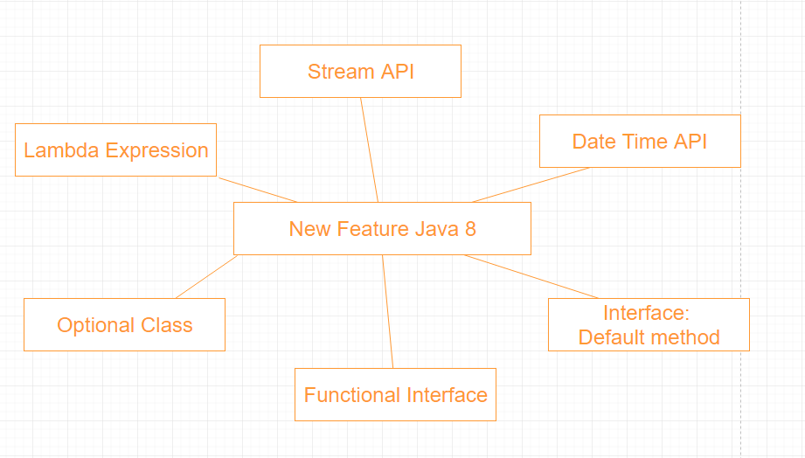

1. Lambda Expression
2. Method references
3. Default method
4. New tools
5. Stream API
6. Date Time API
7. Optional
8. Nashorn, JavaScript Engine

* **Reference**

<https://www.tutorialspoint.com/java8/java8_overview.htm>

<https://techmaster.vn/posts/7978/ngon-ngu-lap-trinh-java>

<https://stackjava.com/java8/java-8.html>